Group BY and HAVING
Display Gender and count from student table
(The count should be gender-based)
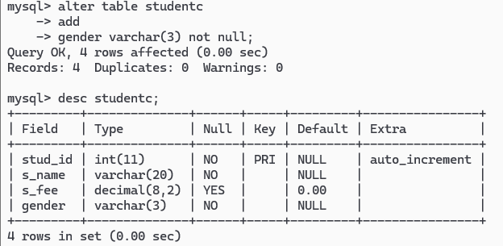
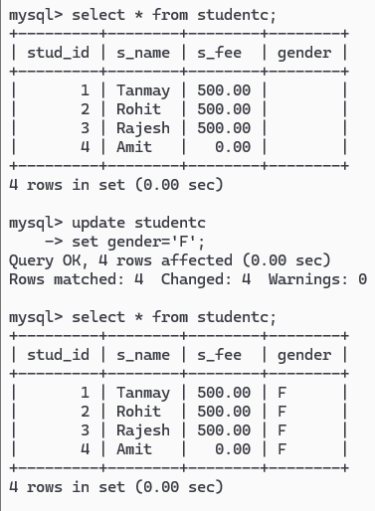
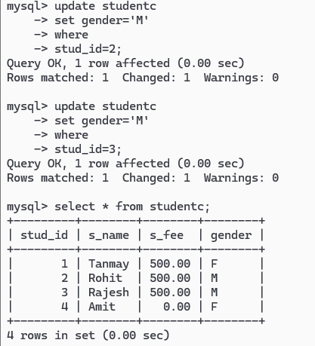
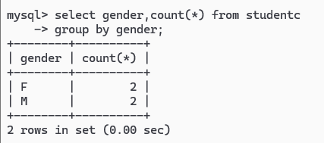

Display Fees count from student table
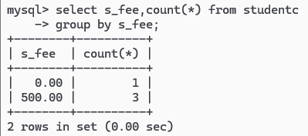
Using HAVING Clause
Display the count of gender where gender count is greater than 2.
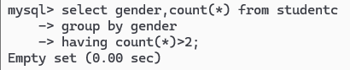
Display the fees data with the count where data should not be greater than 2.
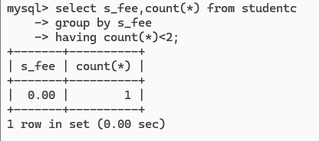

Limit clause
Display only 4 records from student table for fees column.
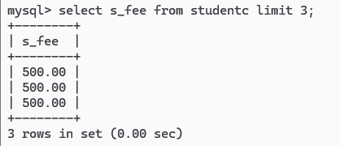

Display fees record from row no. 2 to row no. 4 from student table.
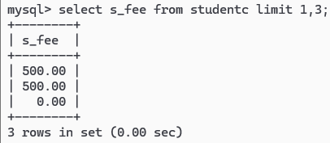

Between keyword
Display all records from student table where student fees are between 100 to 500.
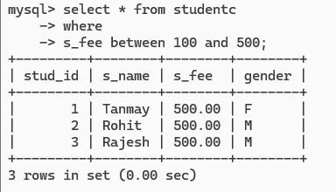

IN Keyword
Display all records of student where fees is (500,800)


